# **Experiment – 12**

**Name – Khushal Agarwal**

**Section – A**

**Roll No. – 201500340 (30)**

**Aim : Implement the following basic commands used in LINUX UNIX OS ( Also perform all the commands with their switches as assignment). ls, man, pwd, who, whoami, date, cal, mkdir, rm, rmdir, cat, head, tail, more, less, cp, mv, echo.**

* **Make Directory :** 
  + **Command -**  mkdir [Directory name]
  + **Description -**  It creates a new directory(folder) with provided name.

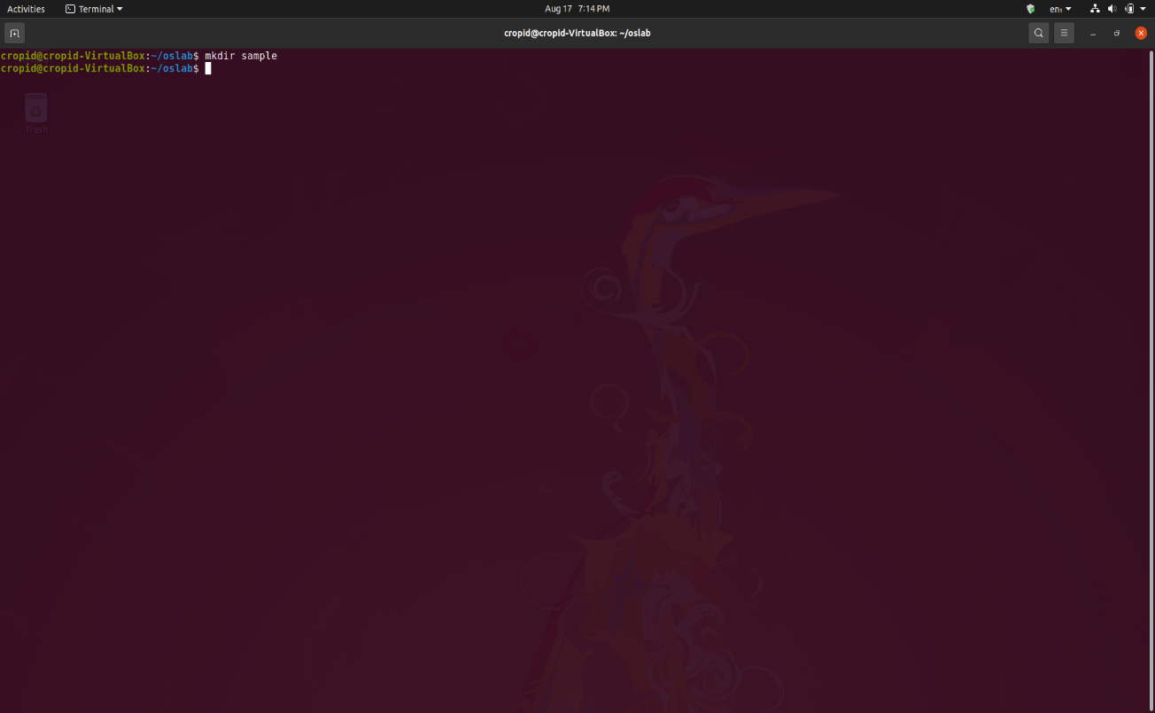

* **List files/directory :** 
  + **Command –** ls
  + **Description –** It list all contents within a directory.

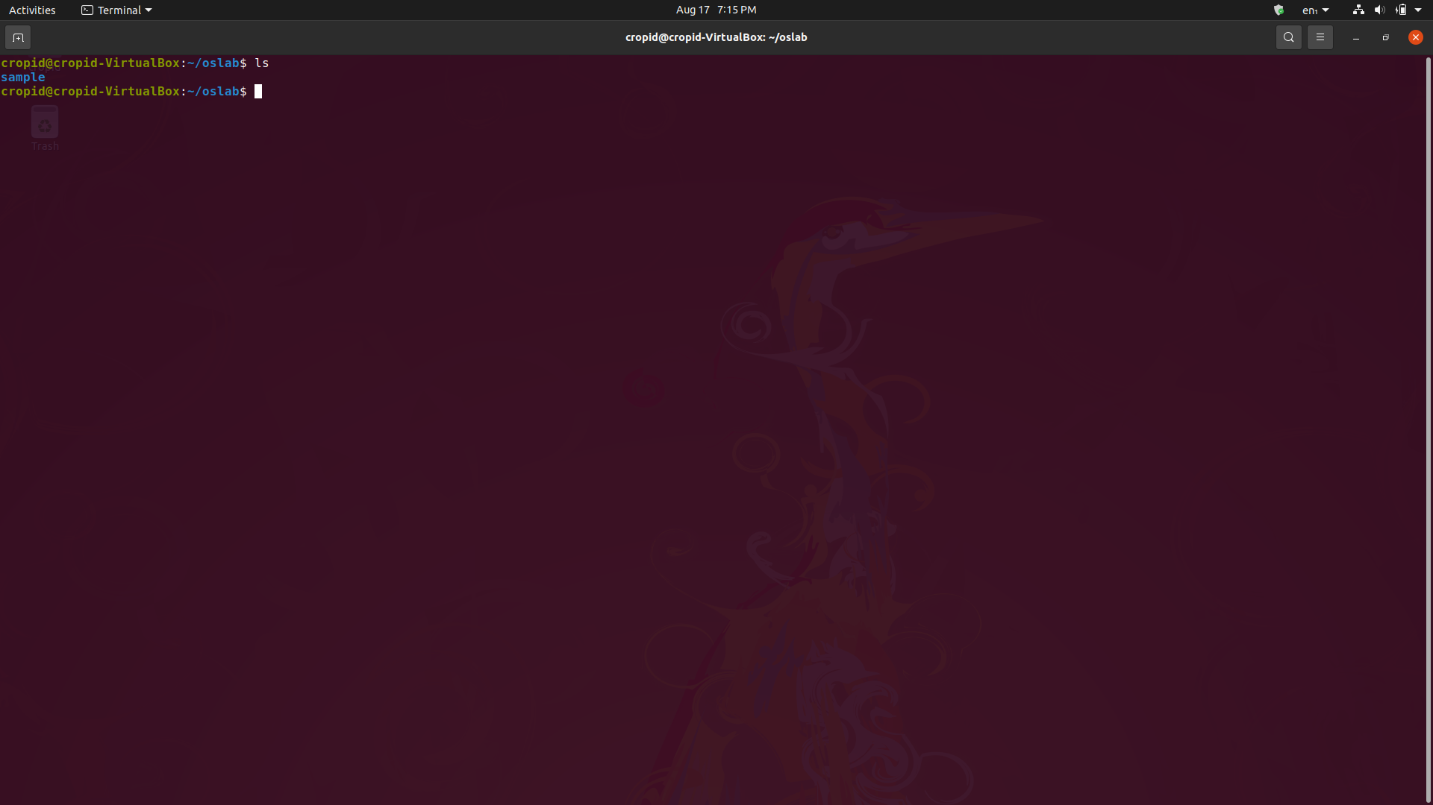

* **Remove Directory :** 
  + **Command –** rmdir [Directory name]
  + **Description –** It removes the directory with provided name.

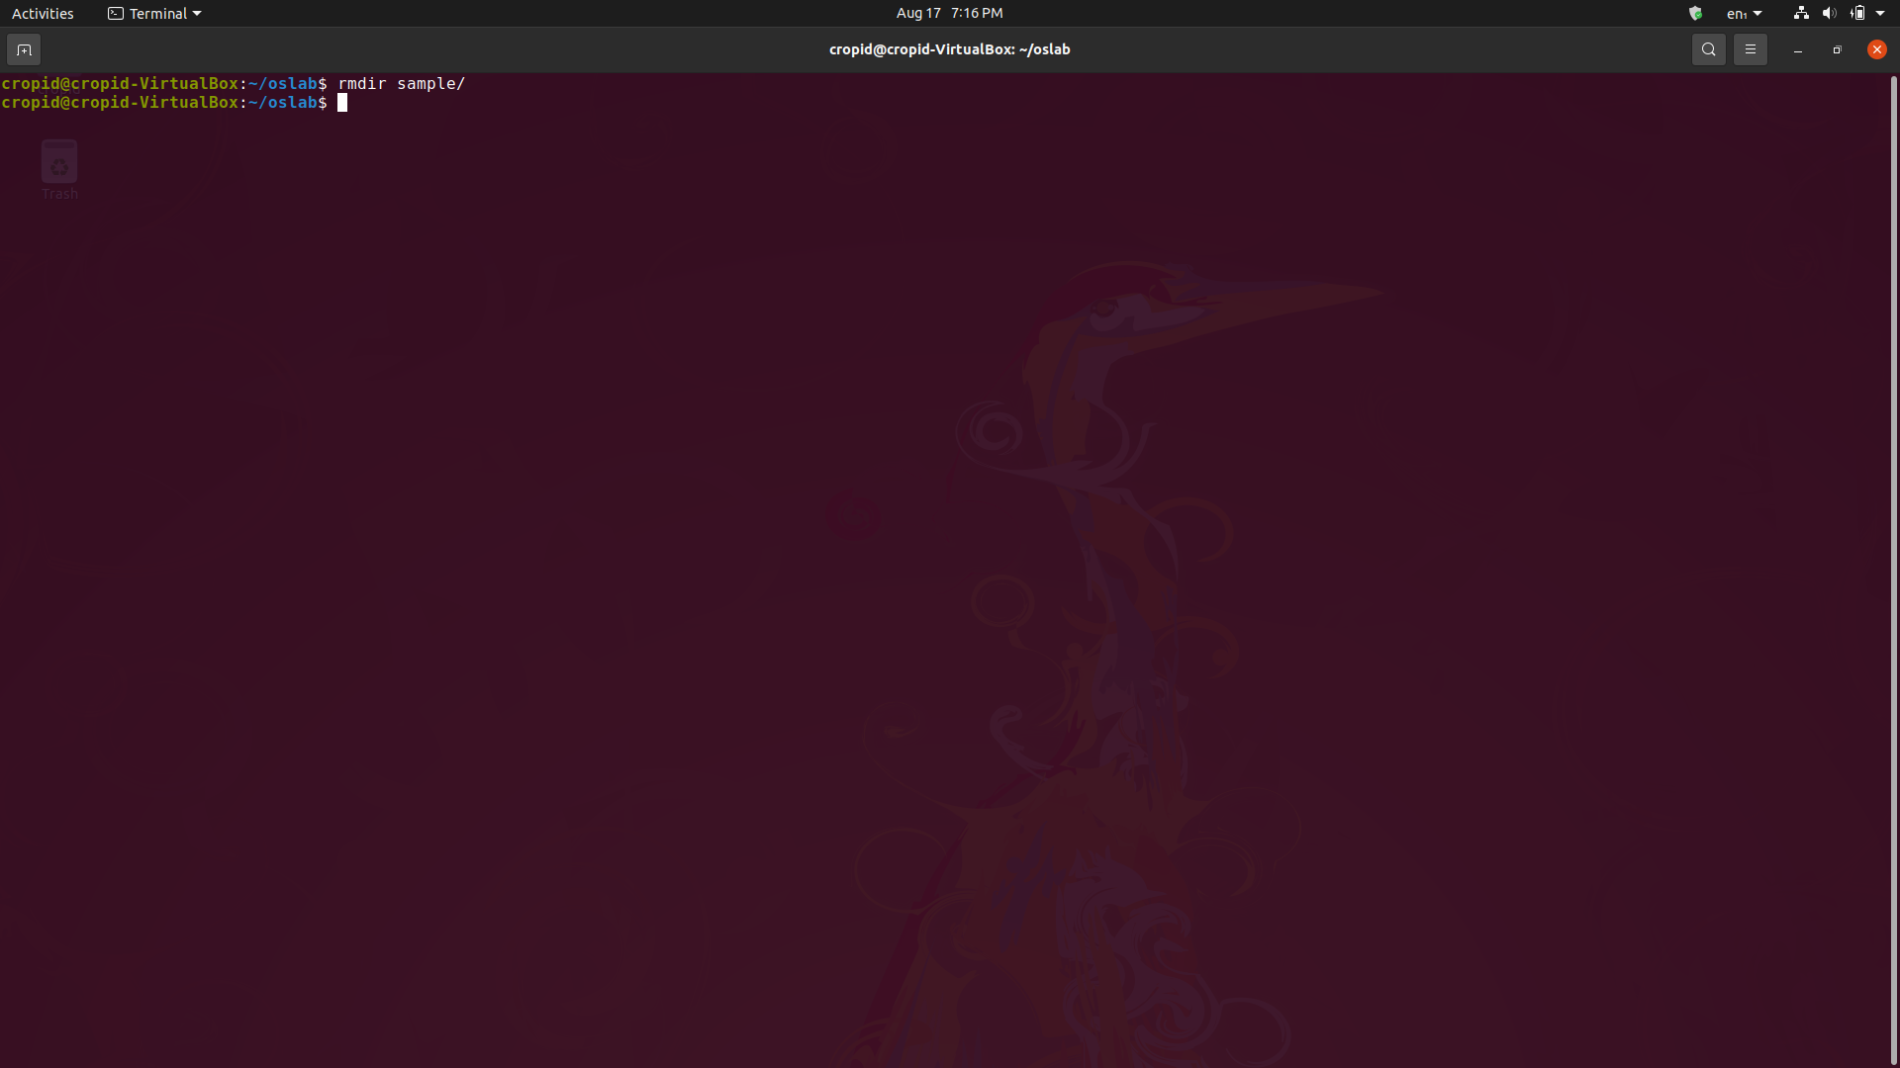

* **Get current date & time :** 
  + **Command –** date
  + **Description –** It prints current date and time on screen.

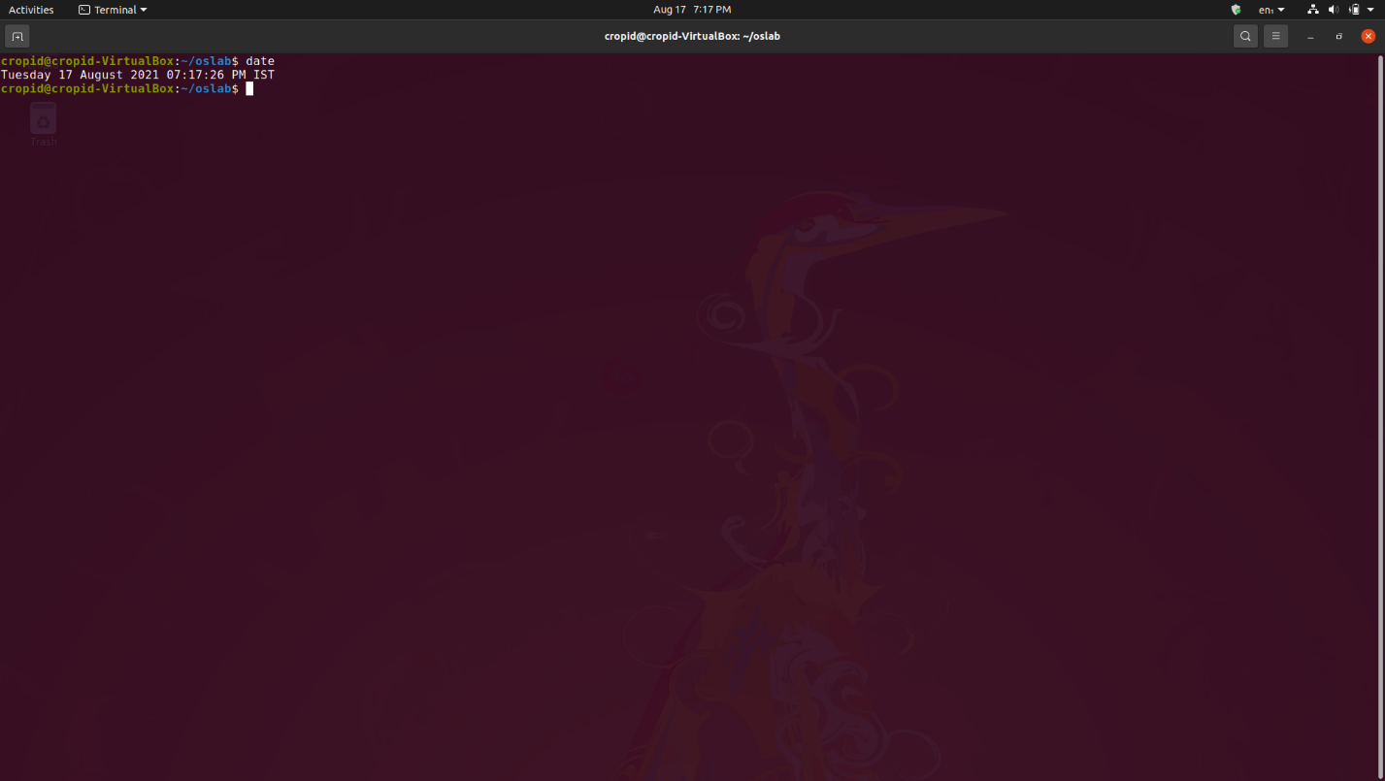

* **Get calendar :** 
  + **Command –** cal <month> <year>
  + **Description –** It prints calendar of current month or given month/year on screen.

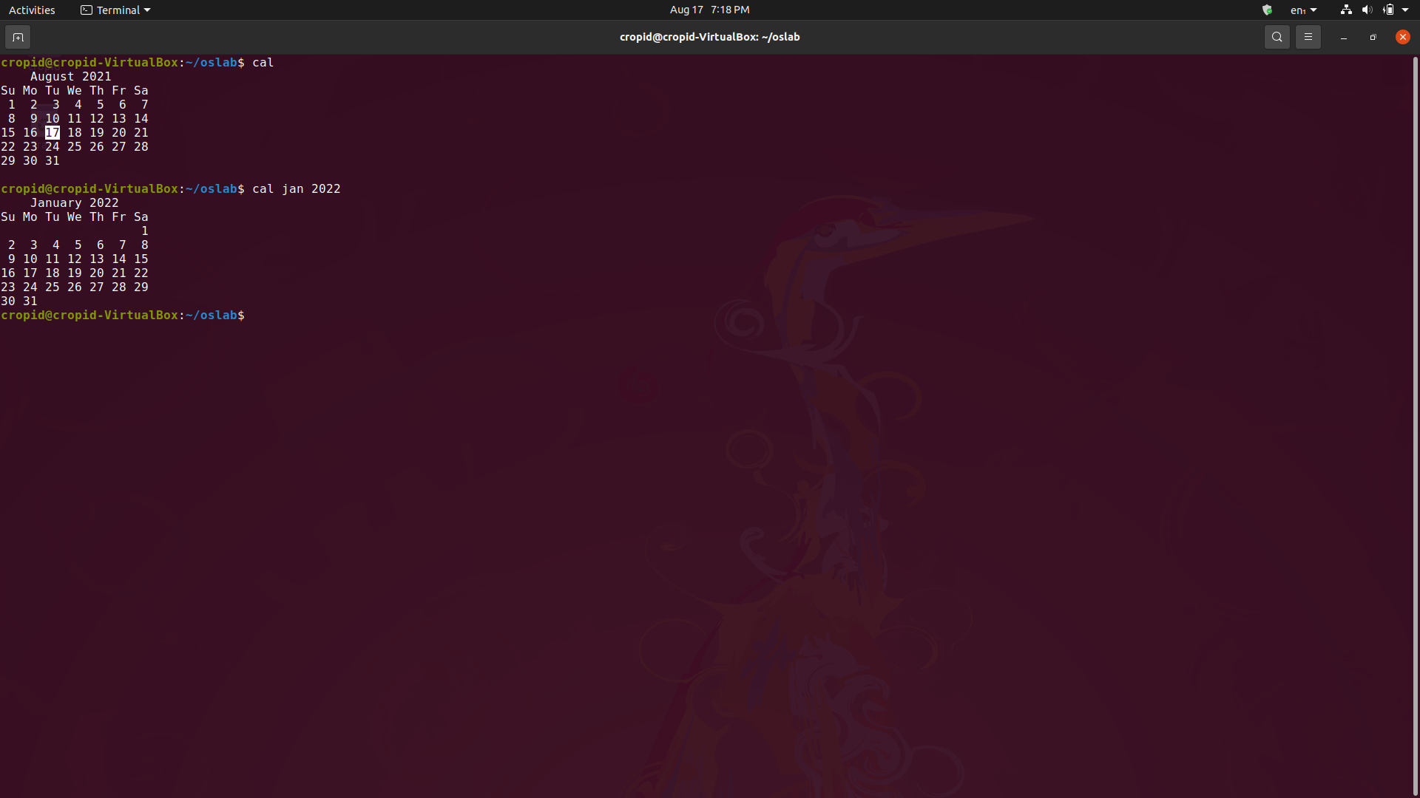

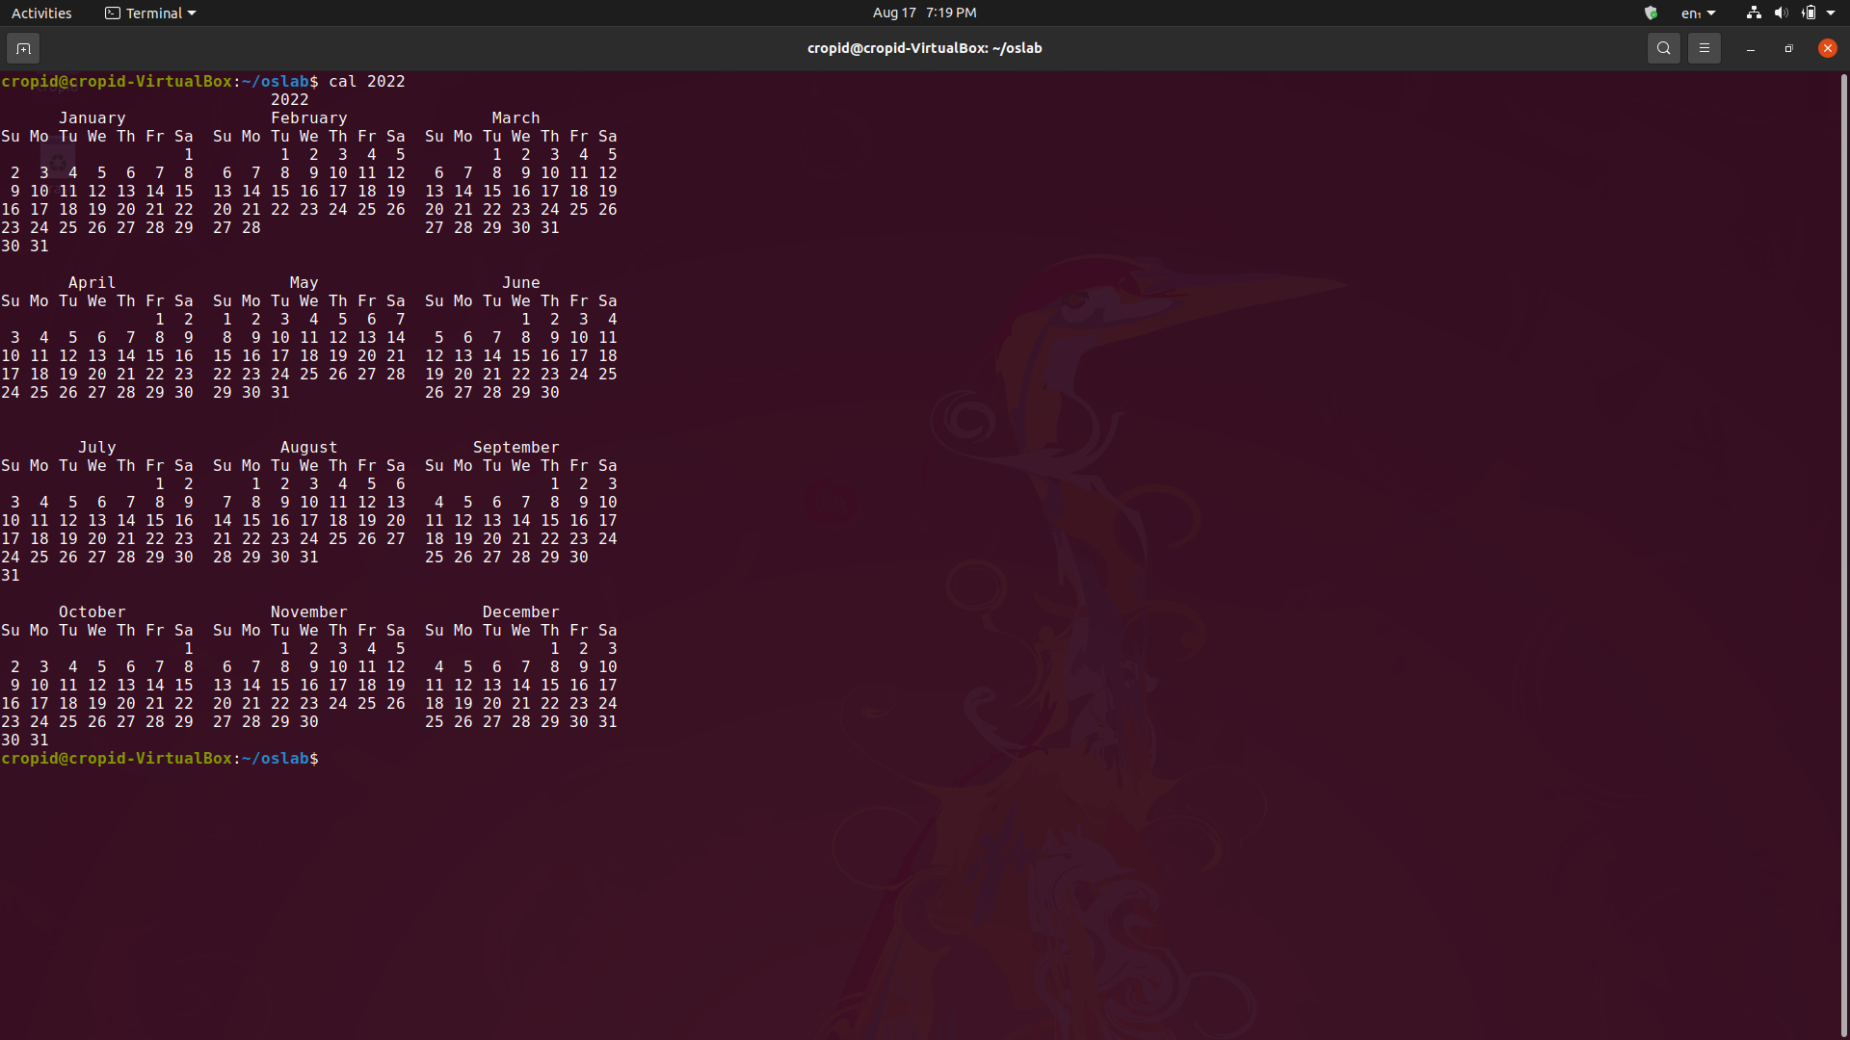

* **Clear terminal window :** 
  + **Command –** clear
  + **Description –** It clears all content present on terminal window.

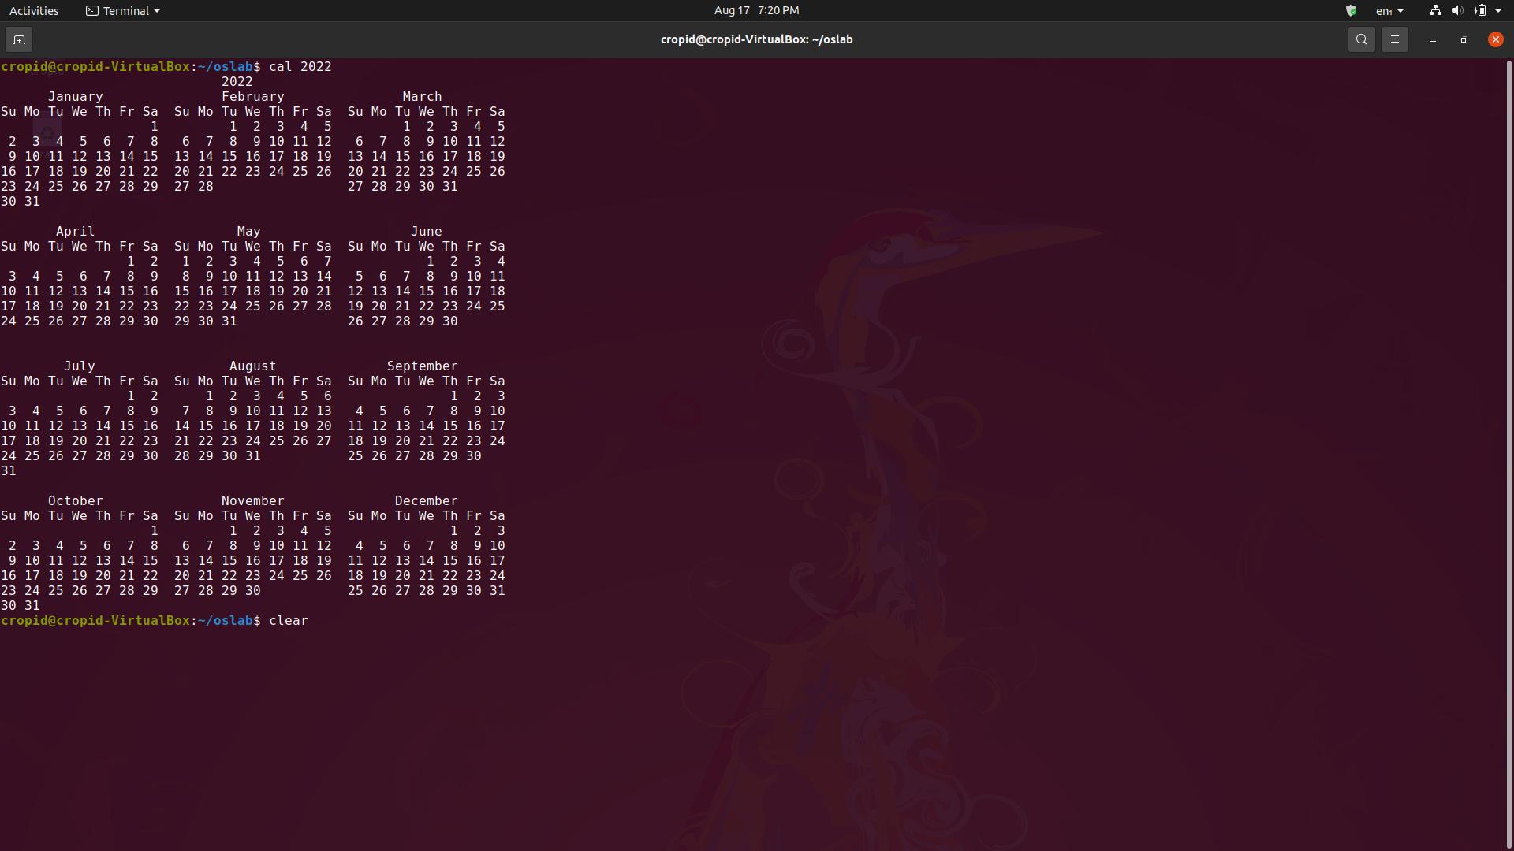

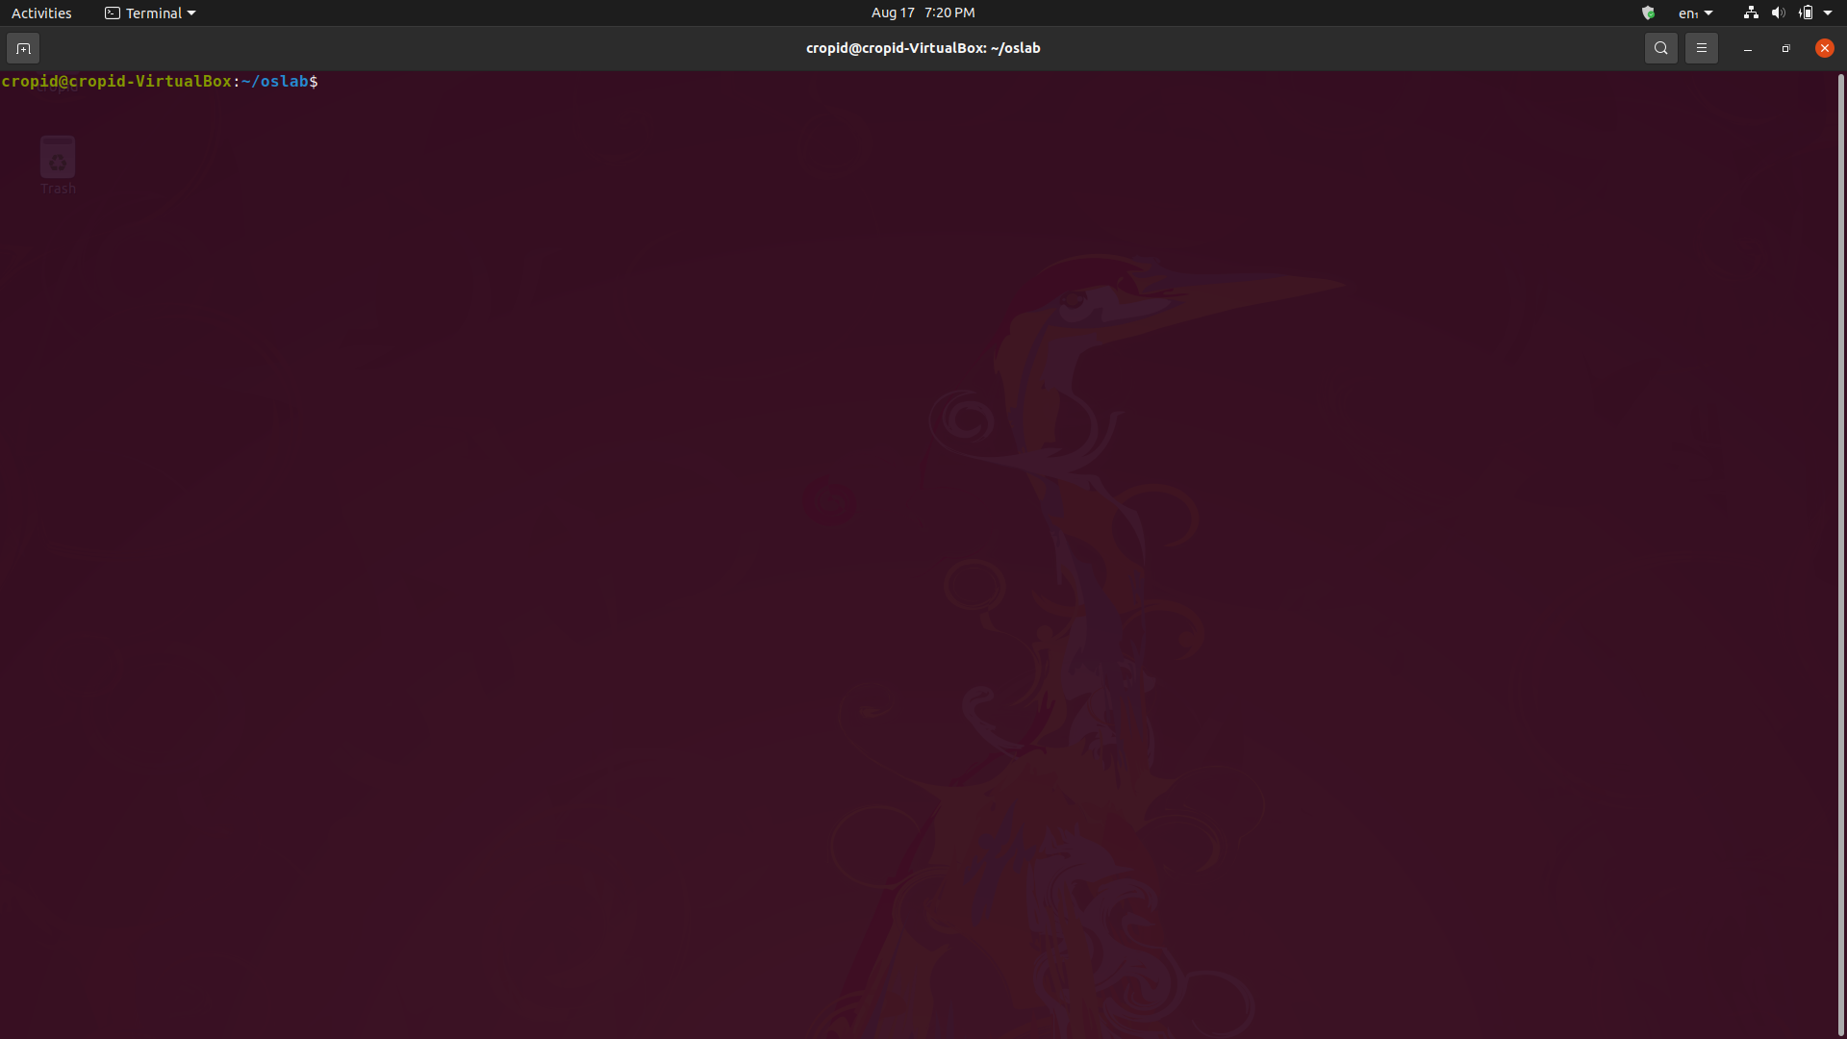

* **Open manual of any command :** 
  + **Command –** man [command]
  + **Description –** It shows the manual of any command which contains all info about that command.

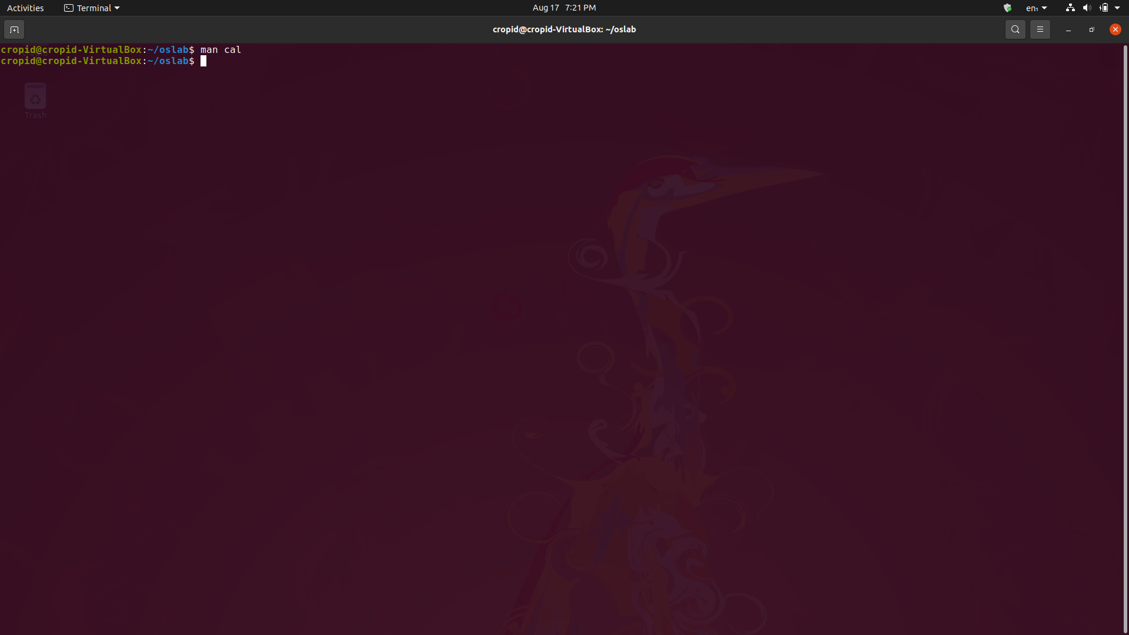

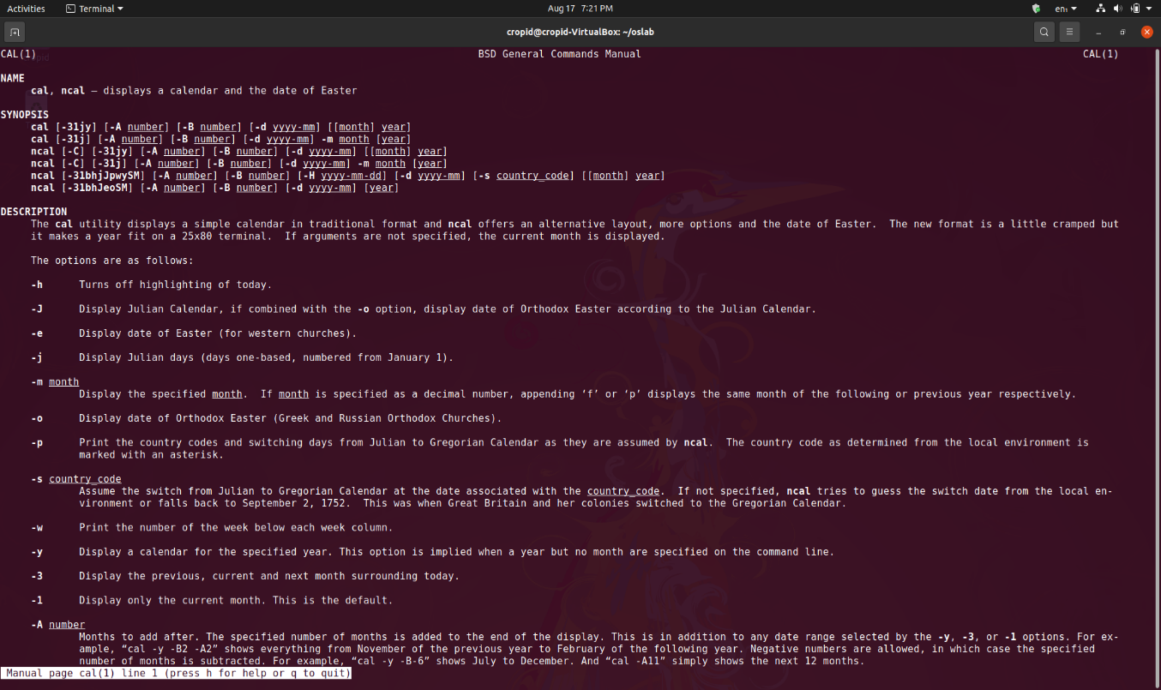

* **Create and write in a file :** 
  + **Command –** cat > [file name]
  + **Description –** It creates a file with a name given and write data in file from std. input till user press ctrl + d.

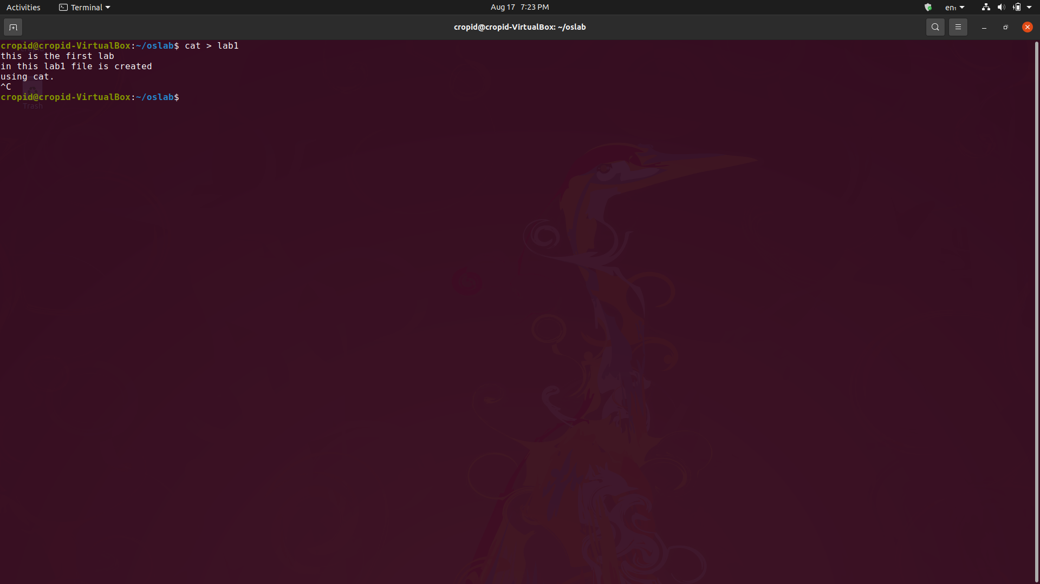

* **Read a file :** 
  + **Command –** cat [file name]
  + **Description –** It prints the file content on terminal.

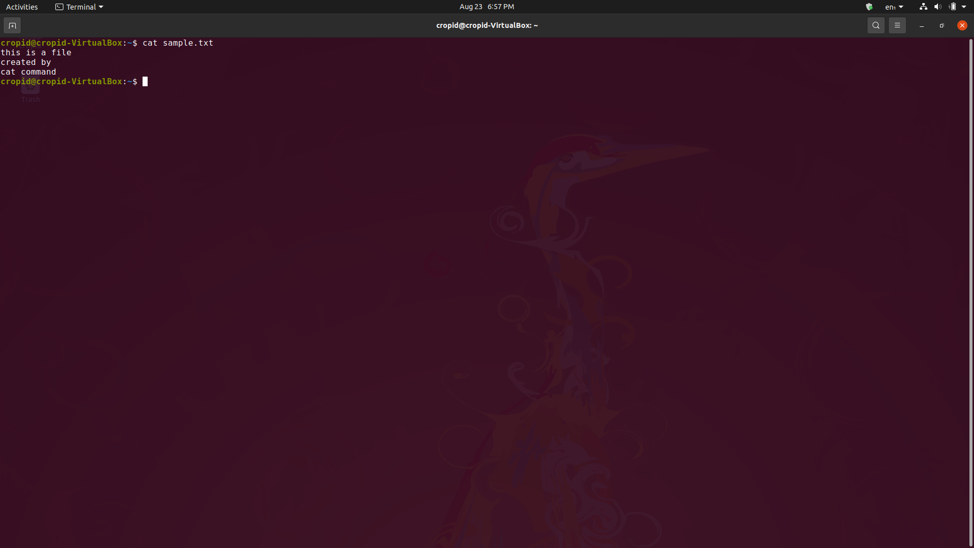

* **Concatinate a file :** 
  + **Command –** cat [file1] >> [file2]
  + **Description –** Cat also refers to concatenate. It concatenate file1 data to file2. ( >> refers to append , > refers to overwrite).

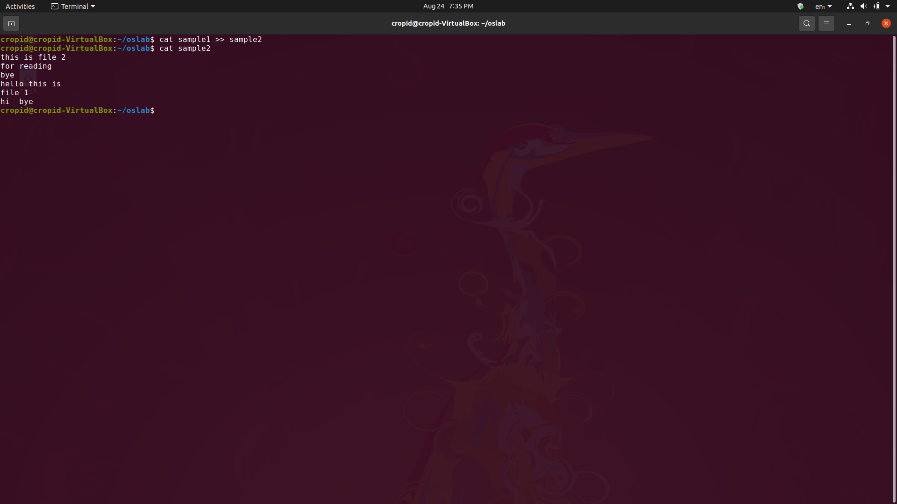

* **Create a file :** 
  + **Command –** touch [file name] or > [file name]
  + **Description –** Both commands create an empty file.

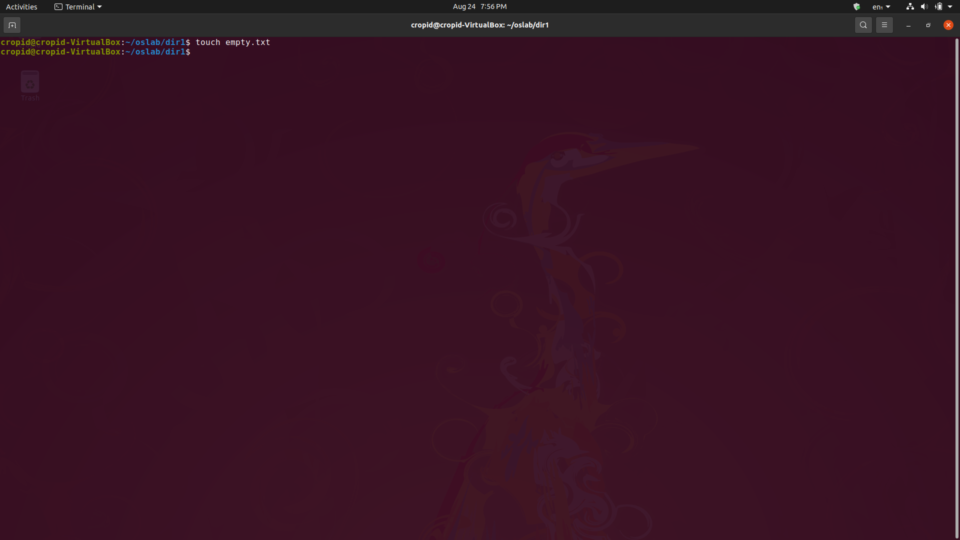

* **Remove a existing file in a directory:** 
  + **Command –** rm [file name]
  + **Description –** It removes the file whose name or path is given.( -r for recursive deletion used to delete a directory).

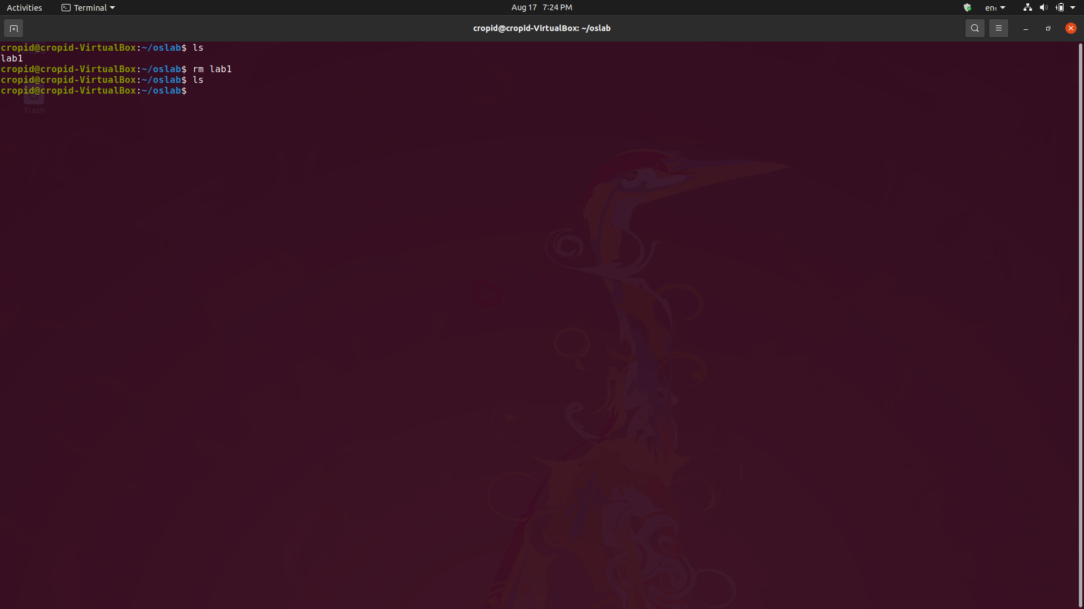

* **Get path of working directory :** 
  + **Command –** pwd
  + **Description –** It gives the path of current working directory.

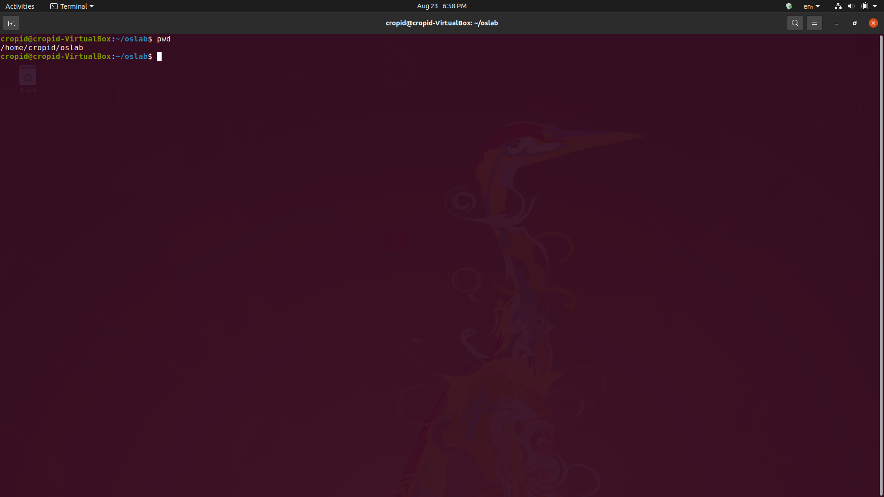

* **Print data :** 
  + **Command –** echo <data>
  + **Description –** It simply print the value of given string or variable on screen.

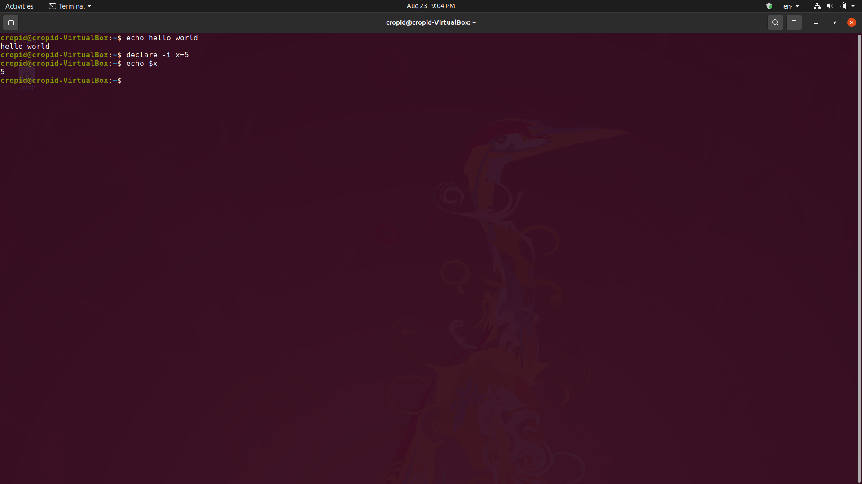

* **Add data :** 
  + **Command –** echo <data> >> [filename]
  + **Description –** It append the given data to the filename given.

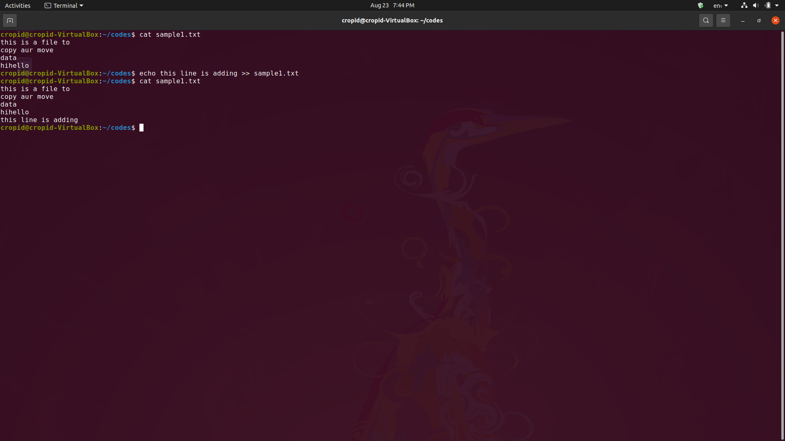

* **Get data from starting :** 
  + **Command –** head -n <no. of lines> [filename]
  + **Description –** It prints the data of file from starting upto the given no. of lines (By default 10).

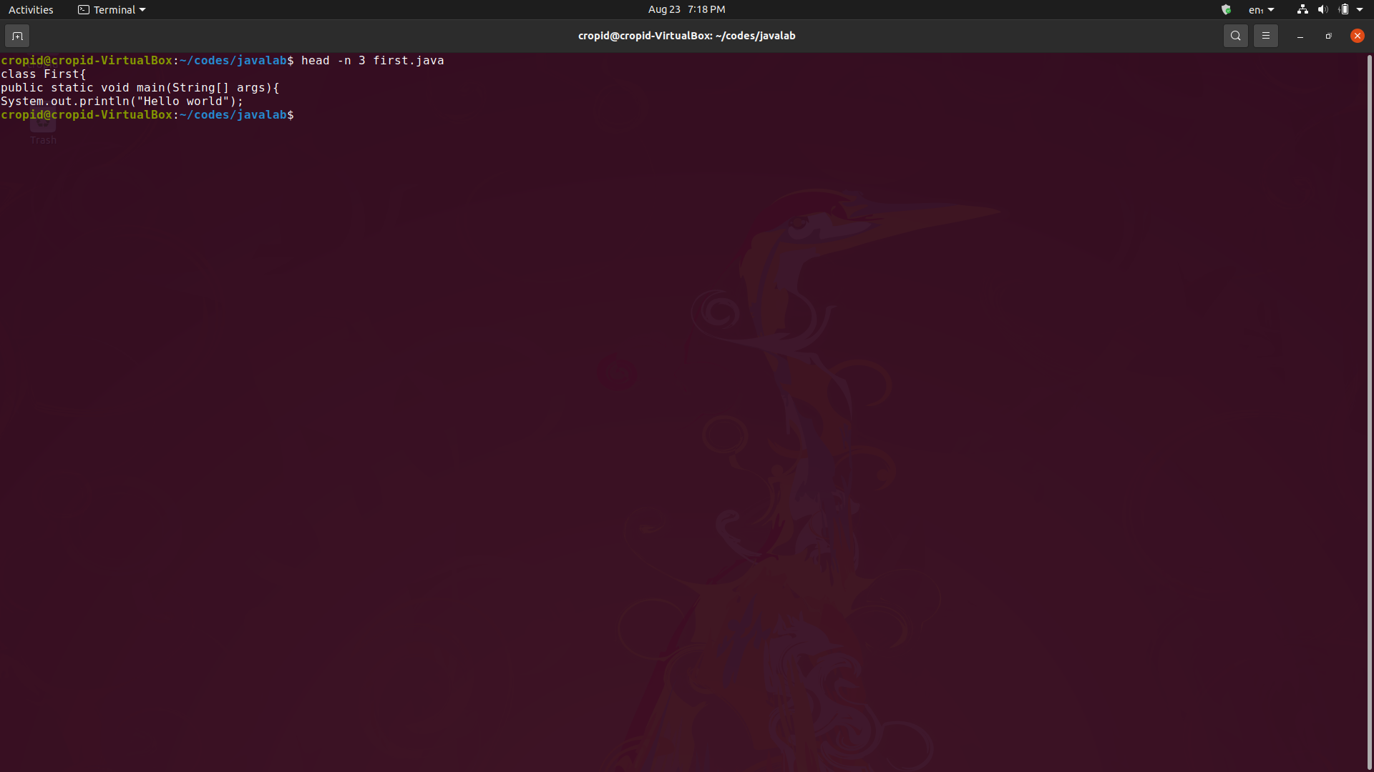

* **Get data from ending :** 
  + **Command –** tail -n <no. of lines> [filename]
  + **Description –** It prints the data of file from last upto the given no. of lines (By default 10).

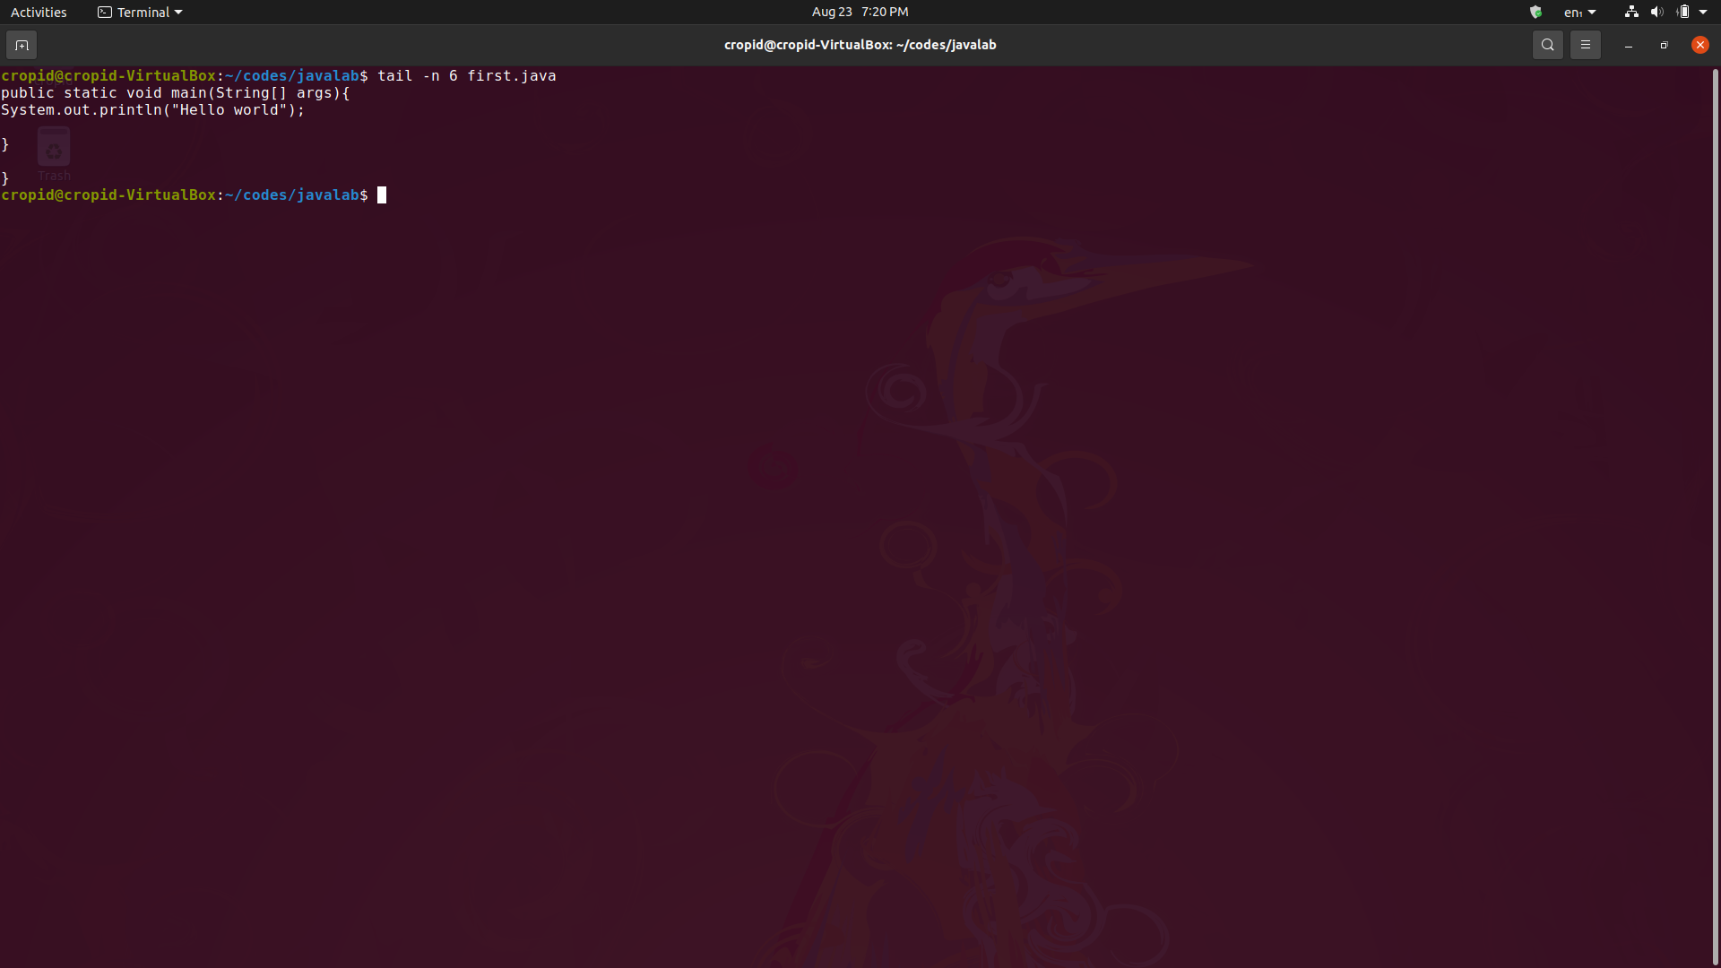

* **Copy :** 
  + **Command –** cp [source path] [destination path]
  + **Description –** It copy the file from source path to desired path.

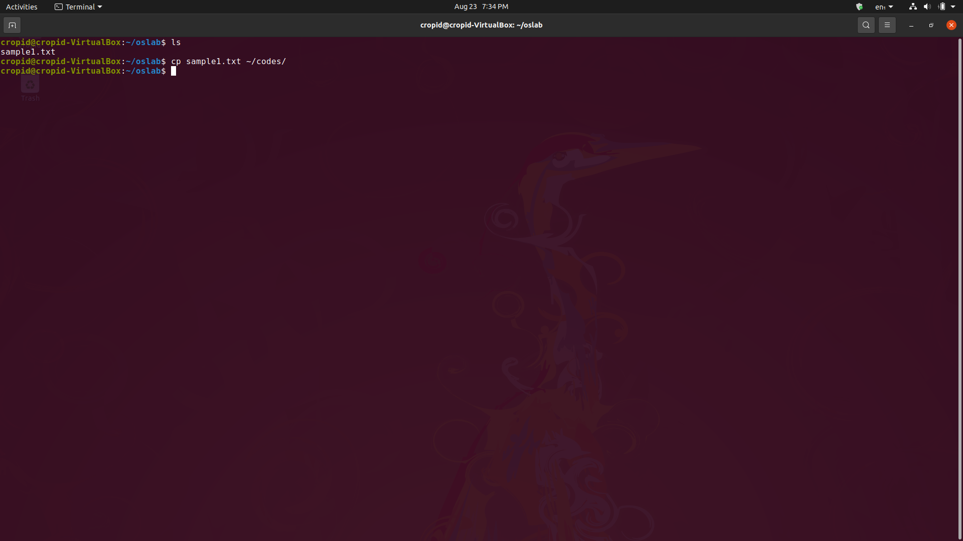

* **Move :** 
  + **Command –** mv [source path] [destination path]
  + **Description –** It move the file from source path to desired path. Also it can be use to rename files.

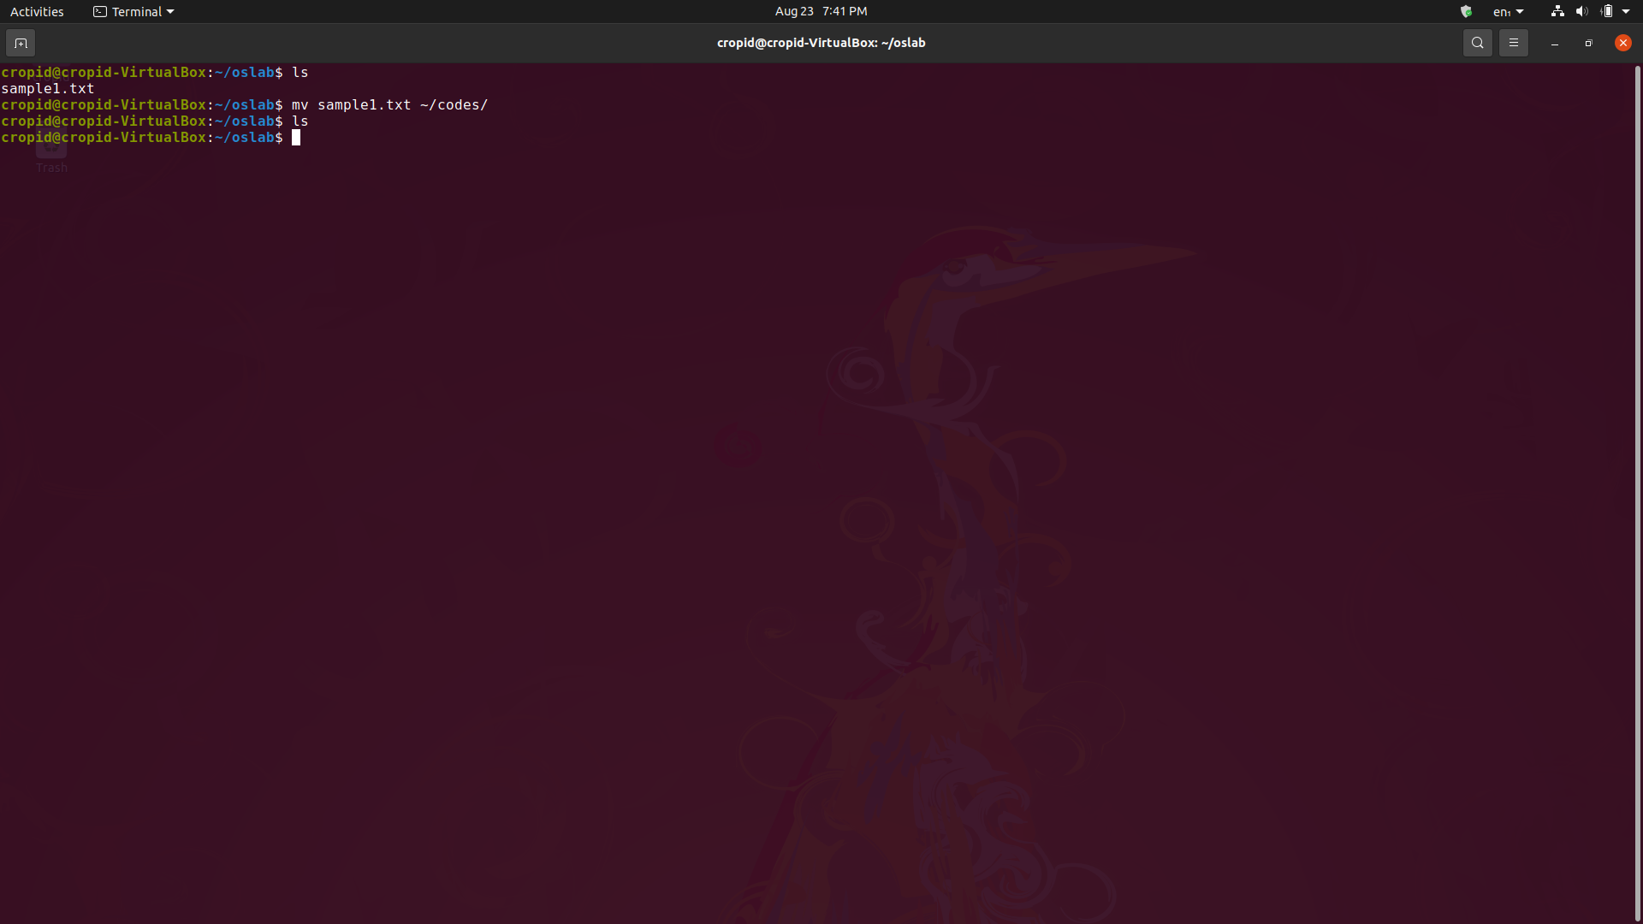

* **List of users :** 
  + **Command –** who
  + **Description –** It display all the users logged in the current session of machine.

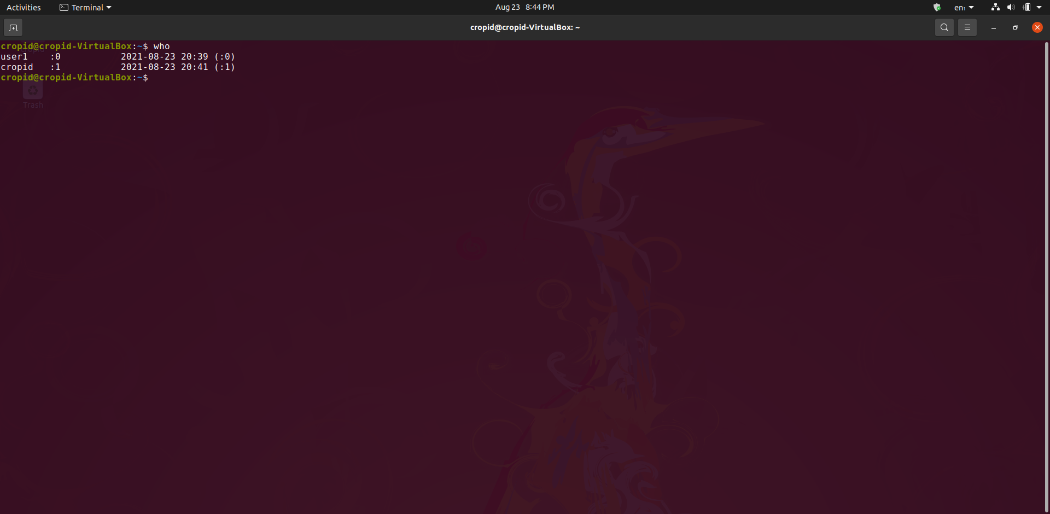

* **Username :** 
  + **Command –** whoami
  + **Description –** It display the name of current user account.

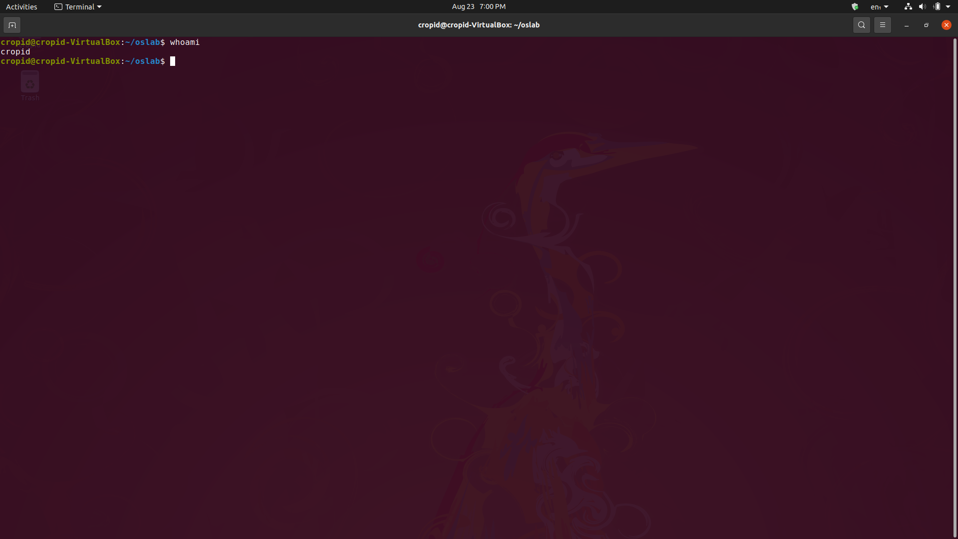

* **Count data :** 
  + **Command –** wc -l -w -c [filename]
  + **Description –** It prints the count of lines, words, and characters in a file or data. (-l for line, -w for words, -c for characters).

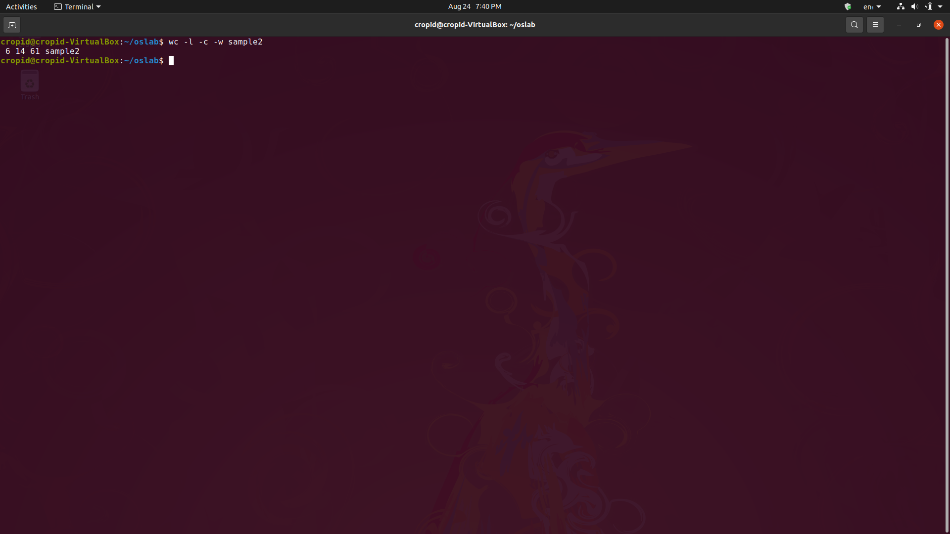

* **Use of more :** 
  + **Command –** more [filename]
  + **Description –** It prints the data till screen gets full and further can be viewed by space key.

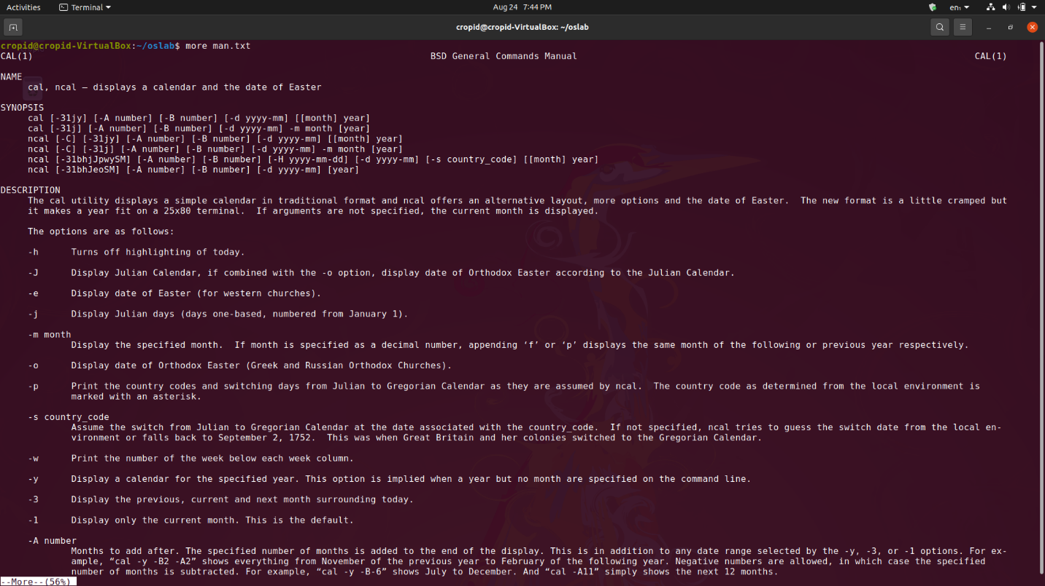

* **Use of less:** 
  + **Command –** less [filename]
  + **Description –** It prints the data till screen gets full and further can be viewed by forward(f key) and backward(b key).

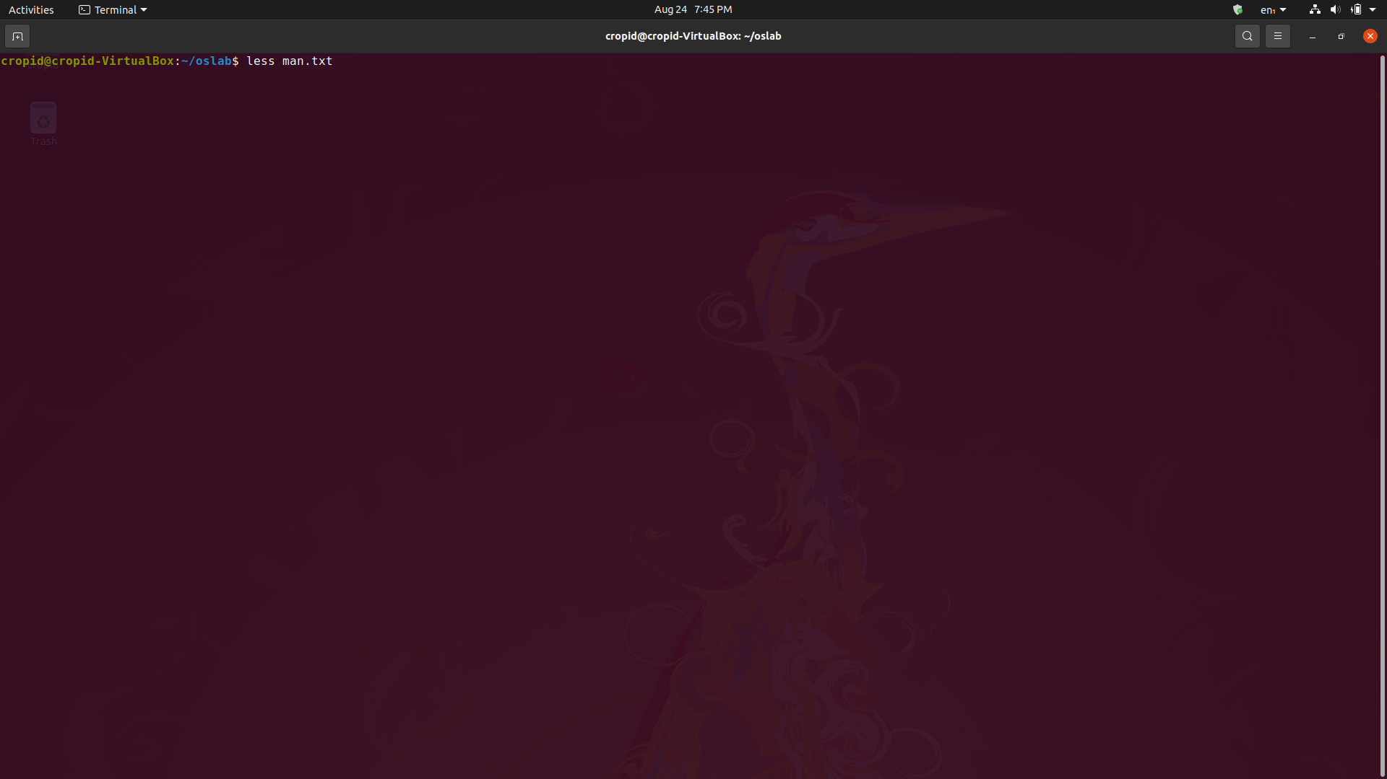

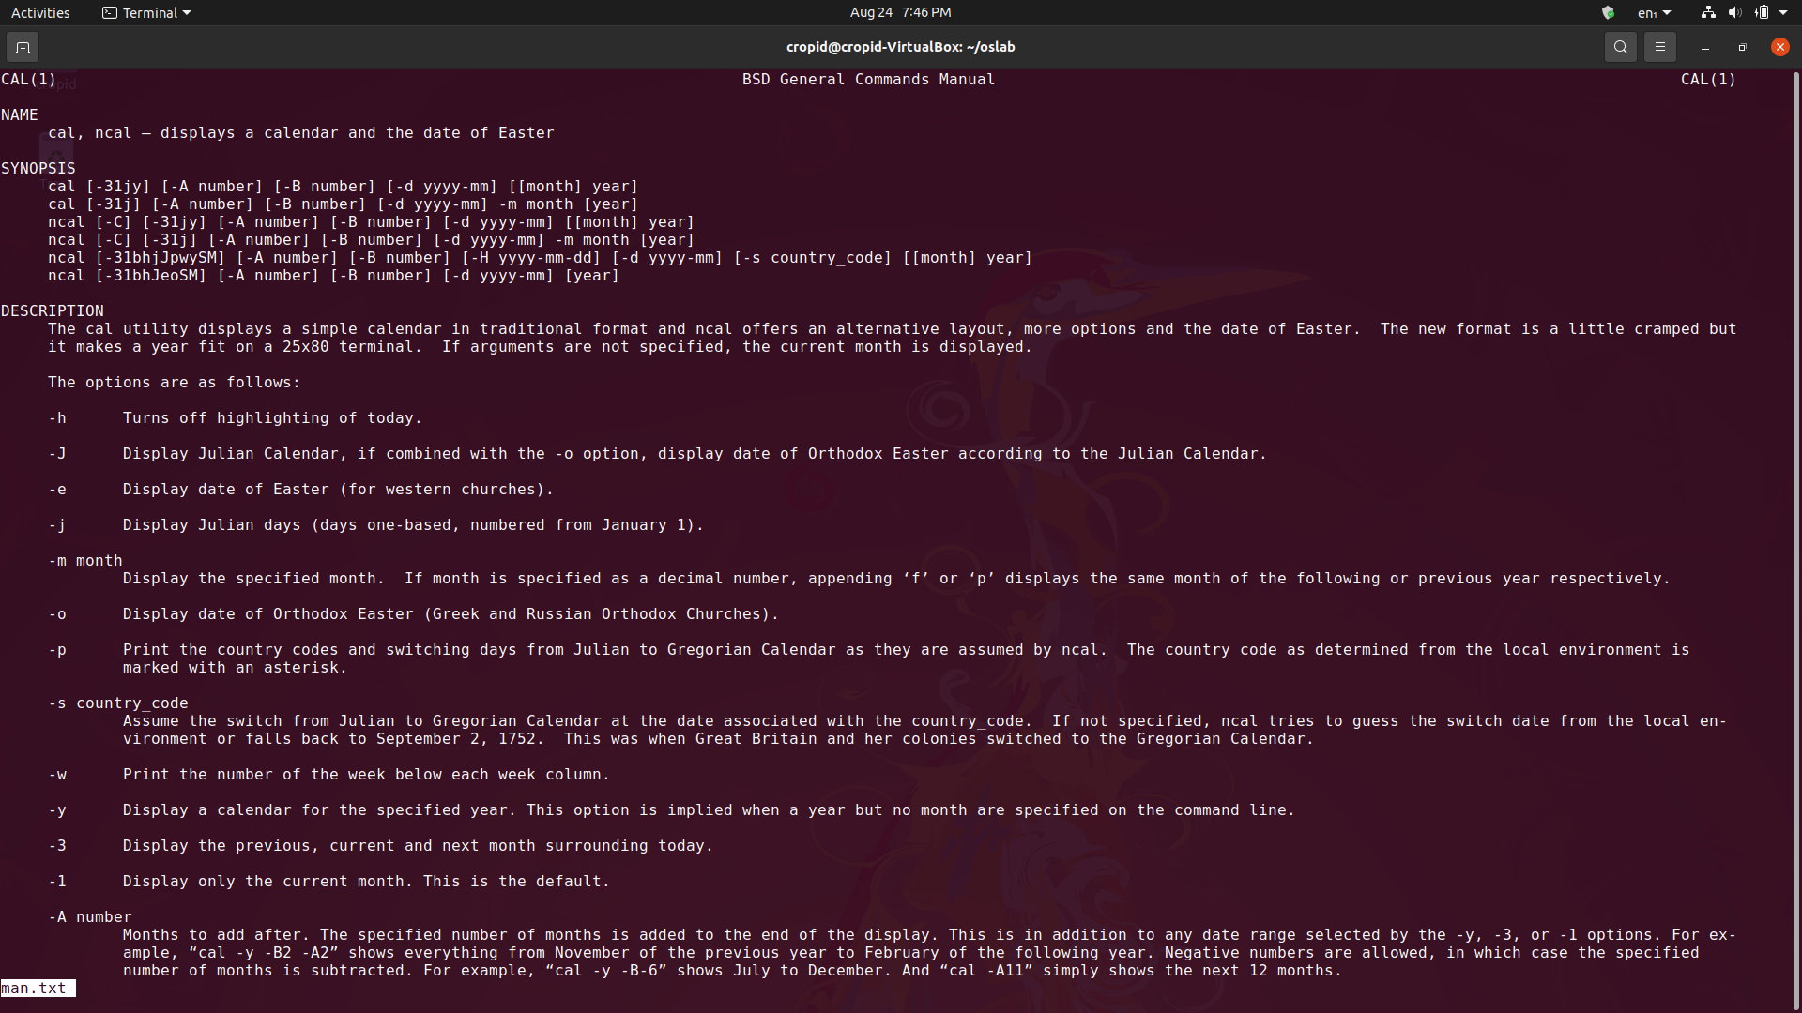

* **Output to a file :** 
  + **Command –** command > [filename]
  + **Description –** It redirect the output of command in the file. (> is used for redirection).

